Basic I Google Presentation Guidelines + Useful Websites

Set Up Account
- http://www.google.com
- I Google in search Engine
- Create a Google Account or sign in if you already have a Gmail account (don’t need Gmail to use I Google)

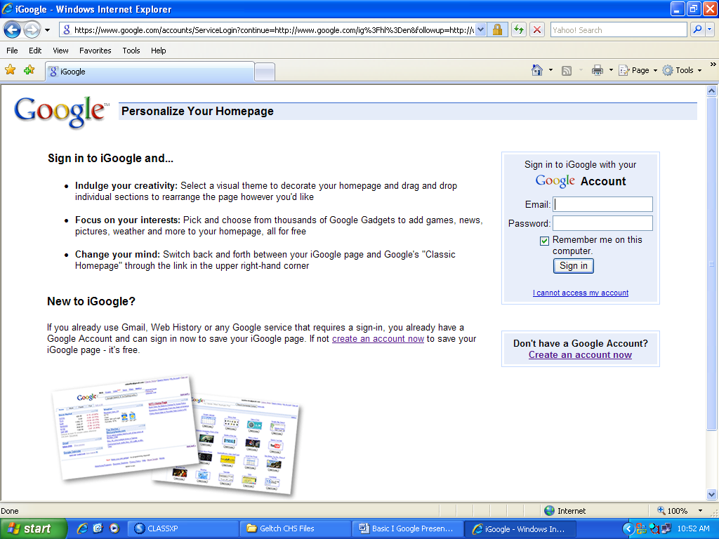

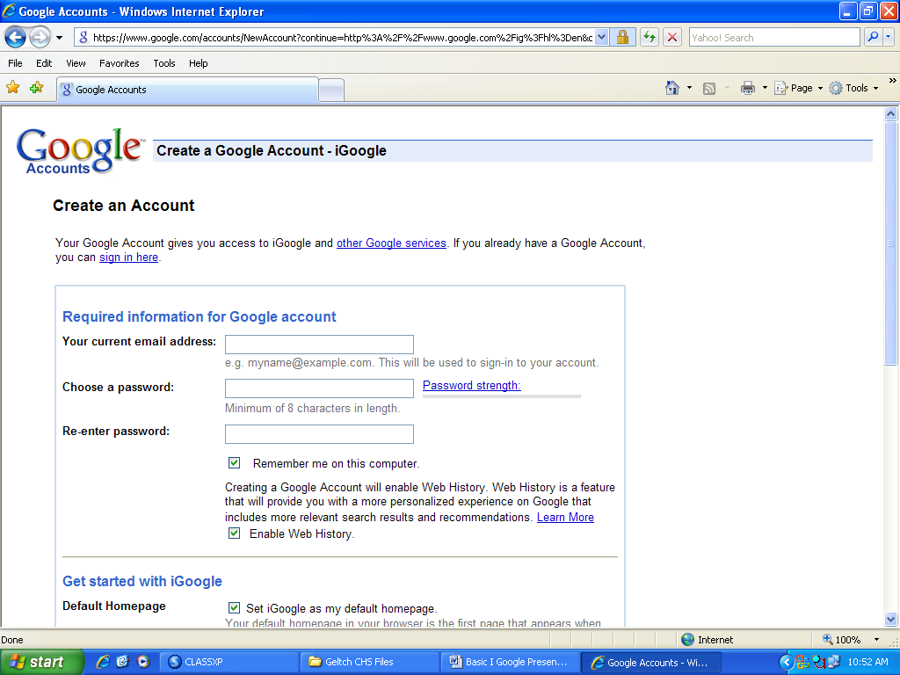

Home

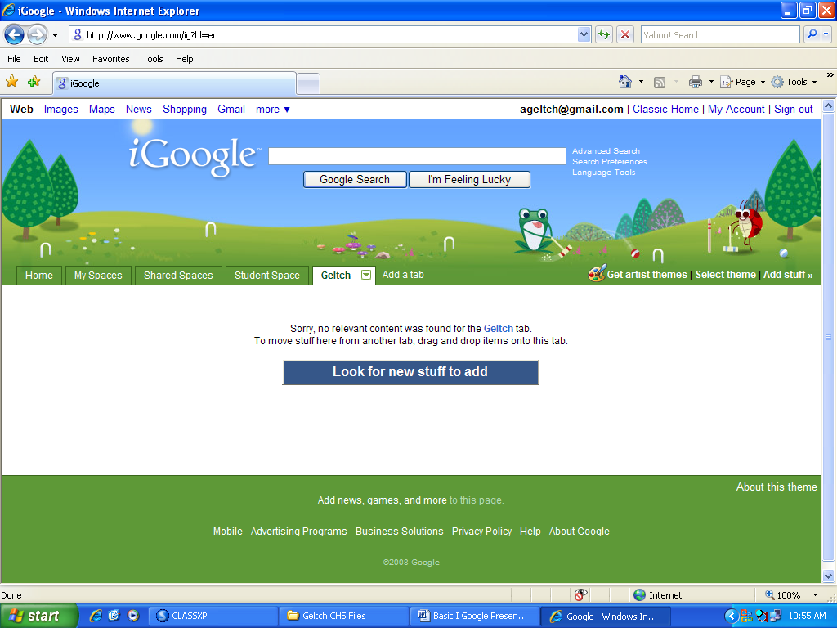
- Select a Theme
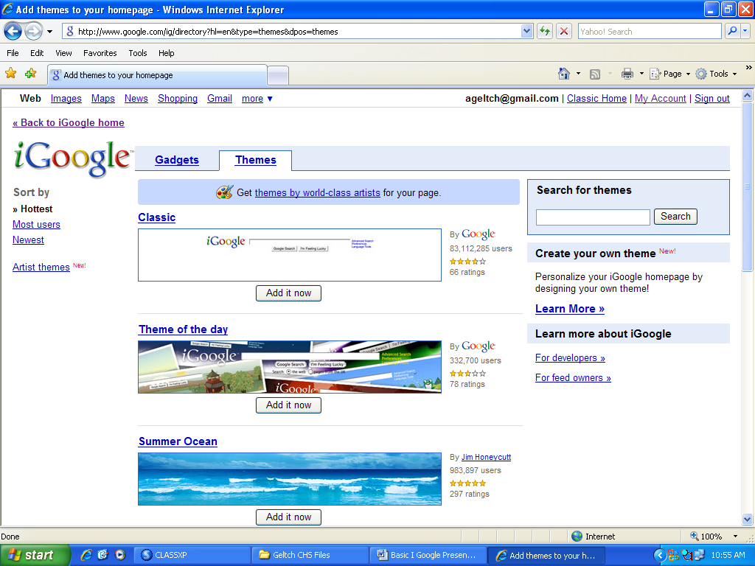
- Add Stuff
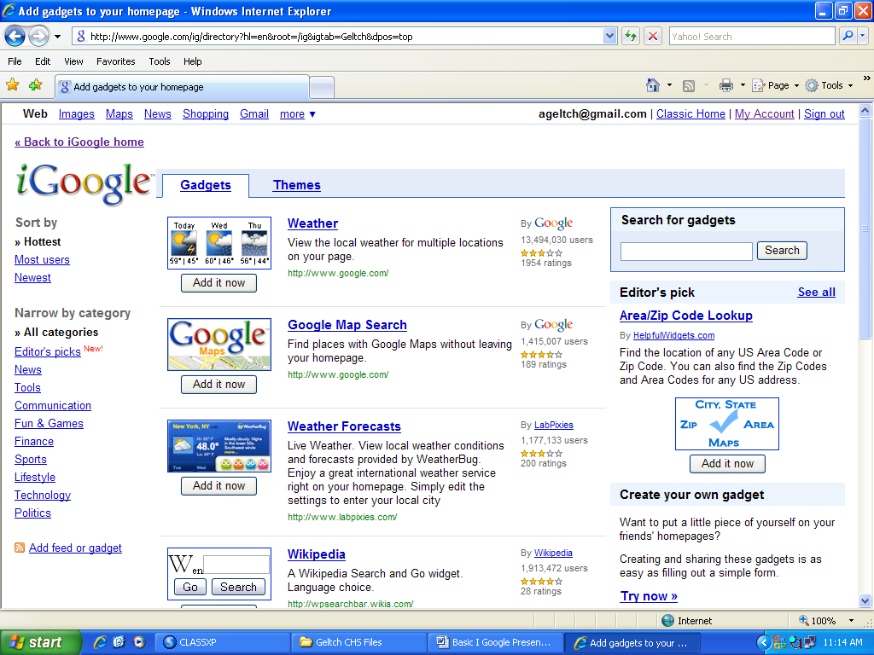

- Search Gadgets-Calendar, To Do List, Email, Quote of the Day
- Website-Add feed or gadget (RSS Feeds)-Orange Swirl-News Article
(ie. CNN, no RSS feed-Website Colton High School Website)

- Hyperlinks
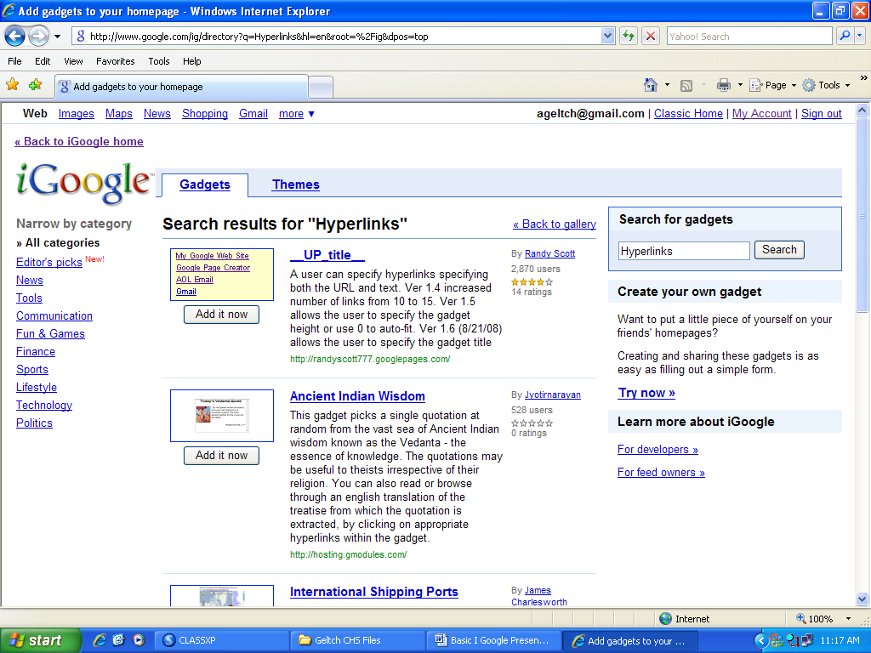

School
- Add Tab
- Name School
- Click on a Different Theme-if desired
- Add Dictionary.com
- Add Multi search
- Add Hyperlinks

Hyperlink 1

ALA Best Free Websites- 1996-2006 http://www.ala.org/ala/rusa/rusaourassoc/rusasections/mars/marspubs/MARSBESTIndex.cfm

Info Please http://www.infoplease.com/

Internet Public Library http://www.ipl.org/

Jiskha Homework Help http://www.jiskha.com/

Ref Desk http://www.refdesk.com/

Teen Advisor http://www.teensadvisor.com/

Hyperlink 2

American Literature on the Web
http://www.nagasaki-gaigo.ac.jp/ishikawa/amlit/authorlist/f_list.htm

Bartelby http://bartleby.com/

British & Irish Authors on the Web
http://www.lang.nagoya-u.ac.jp/~matsuoka/UK-authors.html

Literary Resources on the Net http://andromeda.rutgers.edu/~jlynch/Lit/

Purdue OWL http://owl.english.purdue.edu/

Teen Point-Reading Matters http://www.teenspoint.org/reading_matters/

Hyperlink 3

College Net http://www.collegenet.com/

College Scholarships, Colleges, Online Degree http://www.college-scholarships.com/

College Scholarships Org http://www.collegescholarships.org/

Princeton Review http://www.princetonreview.com/

Vocational Information Center http://www.khake.com/

